Contents
Extend System Calendar (no requirement for 2022) 1
Extend User Defined Calendar (Periods) 2
Extend Balance Calendar 2
Extend Accrual Calendar 2
Extending Company Holiday Schemes 3
Extending Entitlements Per Balance 3
Accrual Balances: 3
Entitlement Balances: 4
Complete Balance Period End 4
Length of Service Scheme Configuration Updates 4
Complete Balance Recalculation 4
Appendix A – Holiday Schemes per Department 6
Appendix B – Length of Service Scheme details 6
Appendix C – Example of Balance Calendar extended for period 2023 7
Appendix D– Full List of Balances 7

Document Version Control
Change History/Review Details
Date | Version | Review by | Summary of Change
01/09/22 | 1.0 | MJOS | Initial draft
05/10/23 | 2.0 | MJOS | Include Entitlement Per Balance General Parameters

Extend System Calendar
The System Calendar must be extended each year to cover the next calendar year. Before extending the System Calendar check and make not of the following items:
Start day of Company = Monday
Last period configured on the System Calendar
Number of weeks in the year

(Already populated up to 2027 – week52 = 04-JAN-2027)

Back Office Core Time > System Params > Calendars > System Calendar
Select Company = 1
Click Calendar Years
Scroll to the bottom of list, click on the last entry and click on the green plus (insert new record) in the toolbar to insert new row.
Enter:
Year e.g. 2023
Start Date e.g. 02JAN-2023
No of Weeks e.g. 52
Save
Click Calendar Periods
Click Generate Period
Enter End Period for the year you’ve just added e.g. 202352 and press enter to auto-populate the Start Date and End Date for the final period of the newly added year.
Click OK automatically generate all weekly periods for the tear.

Extend User Defined Calendar (Periods)
The User Defined Calendar periods must be extended each year to cover the next calendar year.
Back Office Core Time > System Params > Calendars > System Calendar
Select Company = 1
Click on the User Defined Periods button
Select the Calendar Code
Enter the Start Date and End Date and press TAB key to generate the period automatically.
Note – For a monthly calendar, there are 12 periods. Ensure the yearly calendars are extended to cover the periods in your UDC otherwise the period won’t generate.

Extend Balance Calendar
A balance calendar is required per balance and defines the balance periods applicable to that balance. For example, if annual leave is managed in yearly blocks the annual leave balance calendar defines the start and end date of each leave year (period). It is not possible to close a balance period (complete year-end) until the next period has been configured on the balance calendar.
Back Office Core Time > System Params > Balances > Calendars
Select applicable balance
The calendar periods are displayed in the lower section of the screen. Scroll to the last period defined. You can use the ‘Current Period’ button to jump to the current period and then scroll from there.
On the next available line, specify the following details per balance period.
Period = 2023
Start Date = 01-OCT-2023
End Date = 30-SEP-2024
End of Period Limits > Days/Max = 00, Hours/Max = 00
Use By – 31-DEC-2023
Save
Repeat for each balance.

Extend Accrual Calendar
An accrual calendar is required per accrual balance and determines the percent of leave that will be accrued for any hours worked (before any long service increases).
Back Office Core Time > System Params > Balances > Accrual Calendar
Select applicable balance = VARI
On the next available line, specify the following details per balance period.
Start Date = 01-OCT-2023
End Date = 30-SEP-2024
Percentage:
Accrual = 17.12
Hours Min = 0
Hours Max = 9999
Save

Extending Company Holiday Schemes
A Holiday Scheme is a list of closure dates, such as public/bank holidays and departmental fixed closure days. These dates will be treated as non-working days for anyone linked to the Holiday Scheme, via their balance.
Portal WFM Admin Dashboard > WFM Configuration > Configuration Settings > Bank Holiday Schemes
Locate the Holiday Scheme you intend to extend. Click on the ellipses and select view.
Ensure you are on the General Settings tab.
Click Add to enter the extended scheme closure dates. (You need to repeat to add each separate closure day).
Enter
Holiday Date
Pay Code (160 – Public Holiday, 3990 – Fixed Closure Day)
Hours – select calculate
Apply Hours – leave as default ‘all’.
Save

Extending Entitlements Per Balance
Each balance period needs its own set of Balance Entitlements. Accrual balances do not interact with Holiday Schemes, whereas entitlement balances do.
Back Office Core Time > System Params > Balances > Entitlements per Balance

Accrual Balances:
Select applicable balance = VARI
Company = 10
Period = 2023
Element = Floating
Length of Service = LOSVH
Save

Entitlement Balances:
Select applicable balance
On the next available line, specify the following details per balance:
FTE Hours
Period = 2023
Element = Floating
Days =
Hours =
Length of Service – Select the scheme relevant to the balance/FTE
Save
Select General Parameters from the dropdown selection list.
Ensure the ‘Calculate Service on Time in Company’ option has been ticked for the current period. It is recommended to tick for all future periods, which would have been created when following the Extend Balance Calendar process.

Complete Balance Period End
At the end of the entitlement/balance year the Balance Calendars must be closed to calculate new entitlements, apply length of service adjustments, process carried forward values.
Portal WFM Admin Dashboard > Balance Maintenance
For the appropriate balance click on the ellipsis and select view.
Select the Balance Period End tab.
Review the current balance period and ensure the filter is set to return All records.
Select Run Period End
A message displays explaining that this will end the current period for the balance selected. To continue select Yes.
The Run Period End button at bottom right changes to Running Period End. Then shows as Complete when finished.
Repeat for each balances.

Length of Service Scheme Configuration Updates
Update the long service schemes to reflect the application of additional long service leave within the holiday period in which thresholds are reached.
Back Office Core Time > System Params > Balances > Length of Service Increments
Select the appropriate length of service code.
Update Length of Service Increments to populate the correct monthly splits for each category.

Complete Balance Recalculation
Once the Balance Period End has been completed, there is an overnight process, which calculates the balances for employees. To force a Balance Recalculation straight away use the following steps:
Portal WFM Admin Dashboard > Balance Maintenance
For the appropriate balance click on the ellipsis and select view.
Select the Balance Recalculation tab.
Select the From Period for your balance (period just moved into i.e. 2022)
Choose what you want to revaluate, in this instance select Both.
Click Recalculate.
Select Yes to the confirmation message
Repeat for each balances.

Appendix A – Holiday Schemes per Department

Appendix B – Length of Service Scheme details
FTE365 (new)
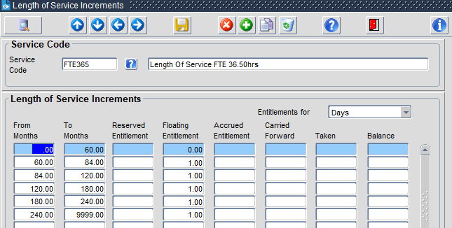
FTE375(new)
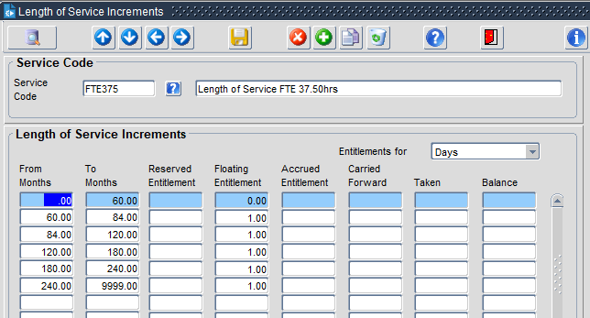
COLCO40(new)
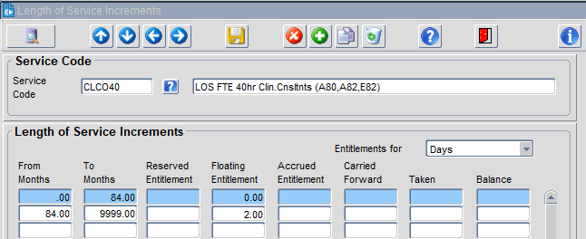
LOSVH(new)

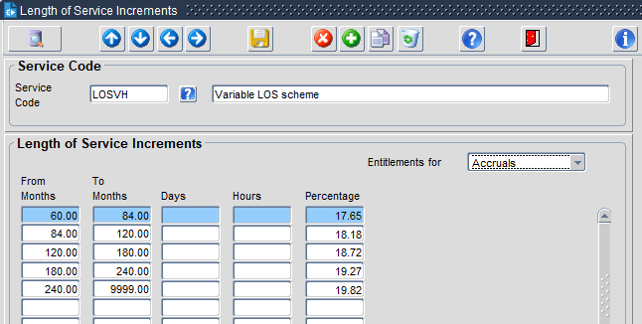

Appendix C – Example of Balance Calendar extended for period 2023
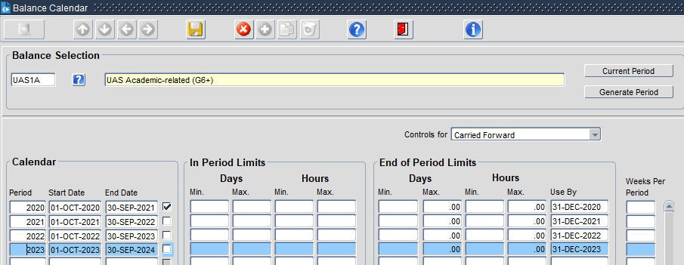

Appendix D– Full List of Balances
VARI and CASUAL= Accrual Balance
Others = Entitlement Balances
